Name:Agnishrota Chakraborty

Reg No. RA1811003010631

Assignment- Using Logs to Help You Track Down an Issue in (Windows)

Problem Statement:

* Updating software that's out-of-date
* Finding and deleting files
* Modifying file permissions
* Finding and terminating specific processes

Solution:

The Windows Update Client service runs in the background on your computer to download and install updates, and patches for your operating system. It does this by checking in with the Windows Update servers at Microsoft every so often, you can learn more in the next reading. If it finds updates that should be applied to your computer it'll download them, if you decided to allow it to, more on that later. Once the download has completed, depending on your Windows Update settings, the Windows Update Client will ask you if it's okay to install the updates or just go ahead and install them automatically.

Command for removing a file in powershell>>

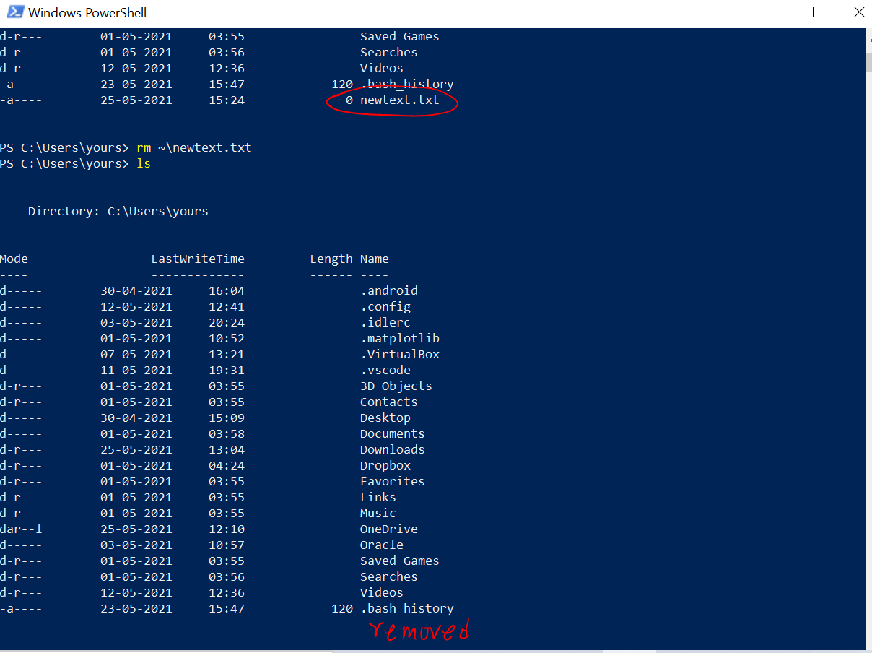

For terminating a process we use the following command >>

**TASKKILL /PID #**

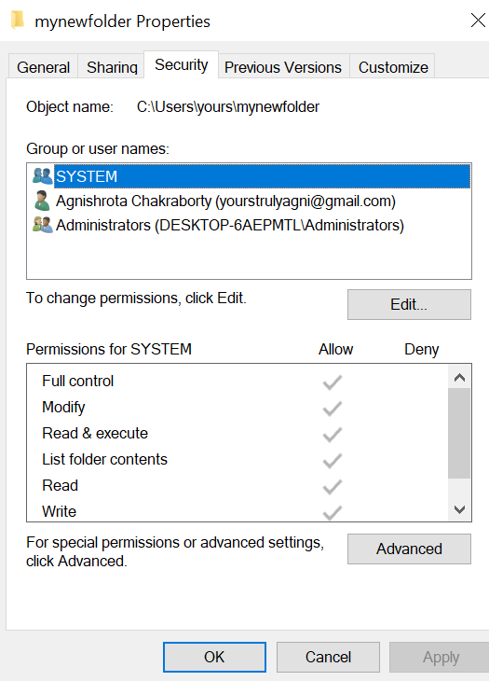

We modify file permissions >> Right click on file/folder>> go to properties>>go to security >> Edit Permissions.

For filtering Events based on critical warning or error level we do the following actions:

**Action Panel >> Create Custom View**

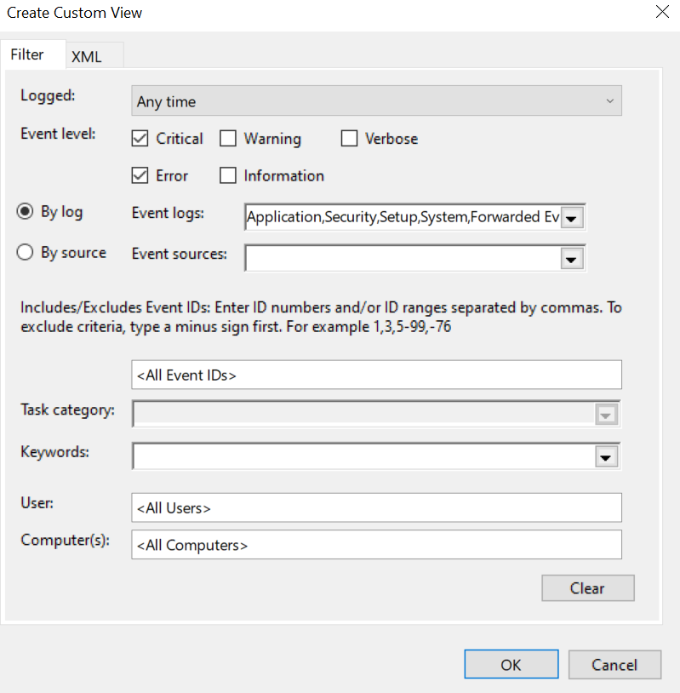

>> Press OK and Name The View

